Local Membership Form (short version)
- By completing this action plan we support the National Dementia Declaration.
- We want to join our local Dementia Action Alliance.
- We commit to the actions below.

Part 1 of 3: Completing actions
Please complete at least 3 actions - you can add more if necessary.
Action 1 title:

What we are going to do:

Action 2 title:

What we are going to do:

Action 3 title:

What we are going to do:

Part 2 of 3: Making a difference
- Consider why you want to be a DAA member. How will you establish what actions are important locally for people affected by dementia?

- How would you want to review the effectiveness of these actions?

Part 3 of 3: Your contact details
Organisation name:

Organisation type - please tick the relevant words that best reflect your organisation

☐ Arts
☐ Care
☐ Communication
☐ Emergency Services
☐ Finance
☐ Health
☐ Hospitality
☐ Medical
☐ Membership
☐ Pharmaceutical
☐ Public sector
☐ Recreation
☐ Research
☐ Retail
☐ Transport
☐ Utility
☐ Voluntary
☐ Other

Contact name:

Address:

Telephone:

Email:

Website address:

What does your organisation do? (Maximum 50 words.)

Can we share your contact details with other DAA members? YES / NO
Area your organisation covers:

Please attach your organisation logo and return this form to:
Lena Maller, Community Engagement Officer, Forest of Dean District Council
lena.maller@fdean.gov.uk
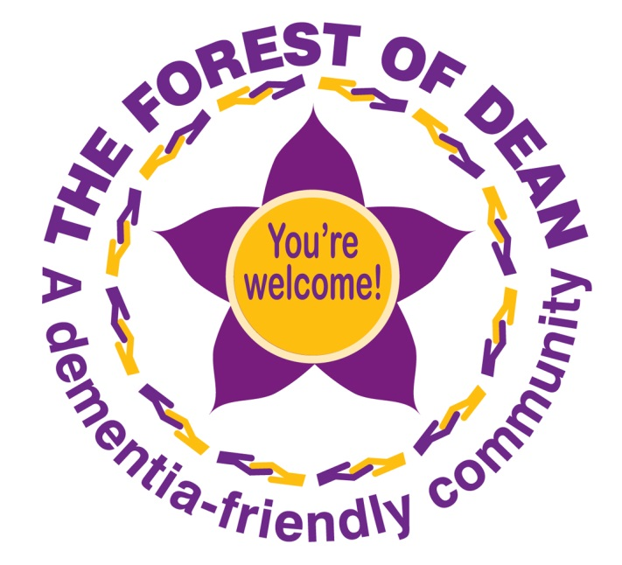
Thank you very much for joining The Forest of Dean Dementia Action Alliance.

