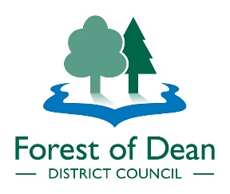
PUBLIC EVENT NOTIFICATION FORM

This form should be completed by event organisers and will be used to inform the Forest of Dean Safety Advisory Group (SAG) about the proposed event. Please ensure you read the information on the Council’s website (www.fdean.gov.uk) prior to completing and submitting this form. This information is available in hard format on request events@publicagroup.uk

Name of Event |  | Date(s) of event
Address of event (including postcode)
Organiser(s) Name |  | Organiser(s) Address
Organiser(s) Daytime Tel No. |  | Organiser(s) email
Event Safety Officers Name |  | Event Safety Officers Address
Event Safety Officers Daytime Tel No. |  | Event Safety Officers Email
Does the event require a licence (contact the Licensing Team if you are unsure) | Yes/No | Does the venue/location have a licence? | Yes/No/NA
If it does not have a licence and it requires one when will this be applied for? |  | If the venue has a licence what is the PREM number?
Overview of proposed event
Include estimated max No of people
Any other relevant Information

Submit this form via email to events@publicagroup.uk

Office Use Only
Date Notification Received
Date Distributed to SAG
Request for event to be discussed at SAG
Date of SAG meeting
Relevant Information

