**Local Membership Form**

**Please complete all the sections below:**

|  |
| --- |
| **Your Commitment:**   * By completing this action plan we are joining the Forest of Dean Dementia Action Alliance which is signed up to the National Dementia Declaration, [*www.dementiaaction.org.uk/nationaldementiadeclaration*](http://www.dementiaaction.org.uk/nationaldementiadeclaration) * We commit to the actions below |

**Organisation / Name: *_________________________________________________***

**Contact Details:**

|  |  |
| --- | --- |
| **Contact name / role** |  |
| **Address** |  |
| **Phone** |  |
| **Email** |  |
| **Website** |  |

*Can we share your contact details?*

Yes ☐ No ☐ *with other Forest of Dean Dementia Action Alliance members*

Yes ☐ No ☐ *the community*

🞏 It is okay to share our membership form on the FODDAA website so others can see what we are working towards.

**Organisation type** -*please tick the relevant words that best reflects what you/your organisation does:*

☐ Arts

☐ Care

☐ Communication

☐ Emergency Services

☐ Finance

☐ Health

☐ Hospitality

☐ Individual

☐ Medical

☐ Membership

☐ Pharmaceutical

☐ Public sector

☐ Recreation

☐ Religious

☐ Research

☐ Retail

☐ Transport

☐ Utility

☐ *Voluntary*

☐ *Other …………….*

*…………………………*

**My/Our Action Plan is:**

Please complete at least 3 actions - you can add more if necessary.

|  |
| --- |
| **Action 1: Title:** |
| **What we/I are going to do:** |

|  |
| --- |
| **Action 2: Title:** |
| **What we/I are going to do:** |

|  |
| --- |
| **Action 3: Title:** |
| **What we/I are going to do:** |

**Are there any challenges to delivering these outcomes for you or your organisation/group/business?**

|  |
| --- |
|  |

**How can you overcome these challenges?**

|  |
| --- |
|  |

**Please do not hesitate to contact us for information or support**

Please **email your organisation logo** *(in either pdf or jpg format)* & return this form to:

**members@foddaa.co.uk**

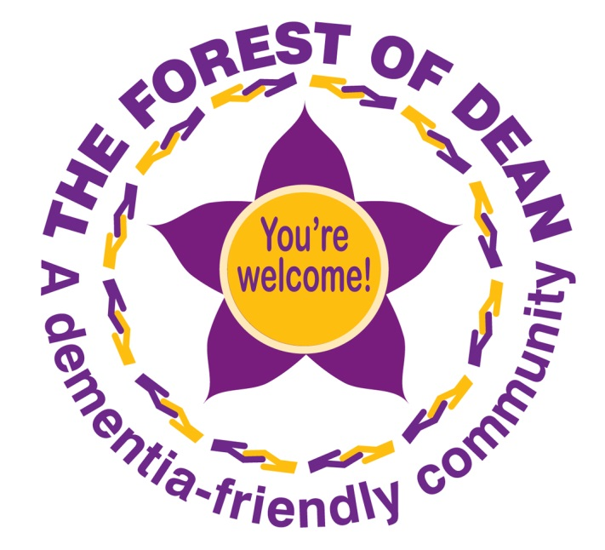

Thank you very much for joining The Forest of Dean Dementia Action Alliance.

Together we can make a difference.