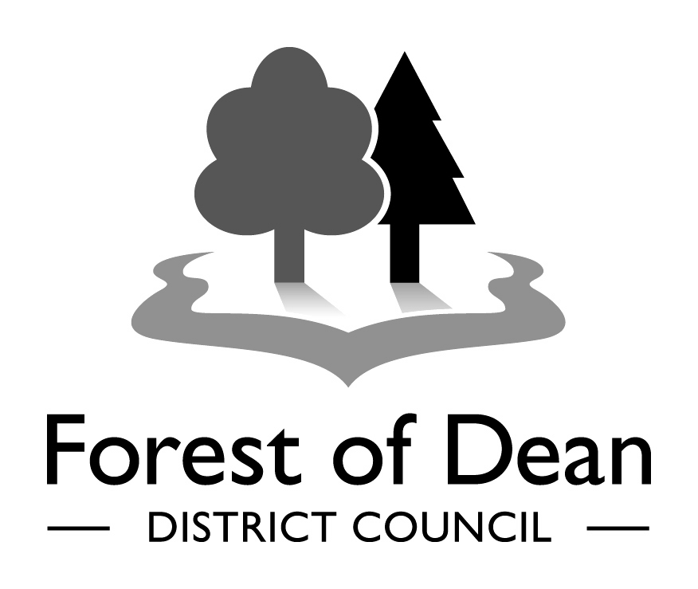 | FOREST OF DEAN DISTRICT COUNCIL  COMMUNITY GRANT 2019-20  APPLICATION FORM

It is essential that you read the Community Grant 2019-20 Guidance Notes before completing this form.

In order to support your application you can contact the Community Engagement Team on 01594 810000 to discuss your project before submitting your application so that they can better understand your aims before it is evaluated against the criteria.

1. YOUR INFORMATION

Name of applicant/main contact
Role within the Organisation
Name of the Group or Organisation
Contact Address
(including postcode)

Telephone Number
Mobile Telephone Number
Email Address
Total amount being applied for
(Please note maximum amounts)
Brief summary of the activity you would like funded.
(No more than 30 words)

2. YOUR GROUP’S INFORMATION

Please all that apply:

Registered Charity |  | Charity number:
Company Ltd by Guarantee |  | Company no:
Charitable Trust |  | Constituted Voluntary Organisation
Community Interest Company |  | Company No:
Other |  | Please describe:

Describe your group -

- What kind of group are you?

- How it works?

- How long it has been running?

- How many committee members do you have? (minimum of three)

- How many members do you have?

Can you demonstrate: | A commitment to equal opportunities both in terms of recruiting staff and volunteers? |  | YES |  | NO
 | Your group or organisation’s commitment and capability to deliver the project successfully? |  | YES |  | NO
Which area within the Forest of Dean will your project be based at and who will be the beneficiaries?

3. YOUR PROJECT INFORMATION

This approach is aimed at building the capacity of the community rather than directly delivering services. Projects should clearly be able to show that there is value in them for their local community, that the project is sustainable and be able have the evidence to demonstrate that it is what the community want. If the project is for a one off activity then you need to show how this is going to have an impact in the community.

Which of the Community Grant’s priorities does the proposed activity address and how? (Please refer to guidance notes).
Have you previously been in receipt of a FODDC Community Grant?
YES |  | If yes, when and for what?
NO
Project/activity timescale

Start date: |  |  | Finish date: (This project must be completed by 31st March 2020).
Brief outline of the proposal. Please tell us the story (To include; How does the project meet FODDC Community Grant aims? Who will benefit from the project and how? What are the community benefits? Demonstrate how you’re engaging with communities to get them actively involved and detail the links you may have with any other clubs or organisations regarding your project and say why you think this project is needed. List anything else that will help us to understand your project).
What age groups will be involved in and benefit from this project?
Please give the approximate number of people who will benefit from the project (please do not put ‘everyone in the area’).
How do you intend to sustain your project and further develop it once the funding period has finished? (We may like to visit your project in future years to record its progress).

4. FINANCIAL INFORMATION

Please supply a copy of your most recent audited account if you are a constituted group.

If you have free reserves of more than twelve months income and you are not spending any of these reserves, please explain why.

Please fill in the tables below even if you also send in your own income and expenditure details separately. This speeds up the assessment and helps us compare applications.

MONEY INFORMATION ABOUT YOUR PROJECT – What will the grant be spent on? Please give us a breakdown of how much your project will cost. For example, will you employ staff, rent buildings, hire facilities or buy small pieces of equipment?

Item | Cost £
Sessional staffing

Rent of buildings/hall or room hire

Equipment (please attach a detailed price list)

Activities

Materials

Other expenses (please specify)

TOTAL

5. MORE MONEY INFORMATION (applications must have match funding either monetary or ‘in-kind’ volunteer time)

Have you previously applied for FODDC funds for this project before from a previous Community Grant or any other grant?
YES |  |  | If YES, from where?
NO
Are you getting any other money for your project? For example, from your own fundraising events or from other grants?
YES |  | If YES, how much? |  | £
NO |  | Where from?
In-kind time (list the estimated number of participants and estimated number of in-kind hours used on this project) Use the attached calculator for this – appendix 1
Total number of Volunteers involved in the project

Total number of volunteer hours (a)  Volunteer rate (b)  (See appendix 1) |  |  |  |  |  |  | ‘a’ multiplied by ‘b’ = ‘c’
Total (c)
(Match funding in volunteer time)

Should you be successful we will pay your grant via Bank Automatic Clearing Service (BACS). We may request an invoice from you.
Account name:

Account number:

Sort code:

NB: If successful, payment of the grant can be released in two phases:
- 50% available as a cash up front payment to bank roll projects
- Release of the balance of the grant will be tailored to the needs of the project; details are negotiated with a Community Engagement Officer following allocation.
Alternatively, full payment can be made at the end of the project

6. DATA PROTECTION STATEMENT
Forest of Dean District Council is the Data Controller for the purposes of the Data Protection Legislation. We will only use your personal information in accordance with the Legislation and for the purposes of the Community Grant. We will not give information about you to anyone else, or use information about you for other purposes, unless the law allows us to.

If you would like to know more about how we use your personal information, please read our privacy notice.

7. DECLARATION

I confirm that the organisation/group named in this form has authorised me to sign this application on their behalf. The information contained in this application is correct, to the best of my knowledge, and I confirm that any grant aid received will be used solely for the purposes specified in the application.

I agree to my name and my organisation’s details being held on paper or electronic files. If this application is successful, in full or in part, the group will keep to the following terms and conditions.

I understand that this is an agreement between the group and the Forest of Dean Community Grant Scheme and understand and agree that:

1. We will use any grant for exactly the purpose set out in this application. The letter which tells us about the award will also explain if the funder wants us to alter any part of this application.
2. We will not make any major change to the project without first receiving the funder’s agreement in writing.
3. We will not sell or dispose of any equipment or other assets which we have bought with a grant without first receiving the funder’s agreement in writing. If we sell any equipment or assets, we may have to pay the funder part of the money we receive for them. The amount we repay will be in direct proportion to the share of the project cost that came from the funder.
4. We will not use a grant to pay for goods or services which we buy or order before we receive the award letter confirming the grant.
5. If we receive a grant for a pilot project, we understand that the funder will not automatically fund any later projects.
6. We will not change the sections of our constitution which relate to purposes, paying members of the governing body, distributing assets or admitting members without first receiving the funder’s agreement in writing.
7. We will inform the funder of any changes to our bank or building society account.
8. We will comply with any relevant legislation affecting the way we carry out our project.
9. We will acknowledge the funder’s grant in our annual report, our Chair’s or Secretary’s report at our AGM, the accounts which cover the period of the grant and in any publicity materials we produce about the project. We will supply copies of these documents to the funder if requested.
10. We will show the grant separately in our annual accounts as restricted funds and will not include it under general funds.
11. The funder can use our name and the name of our project in its own publicity materials. We will inform the funder of any situation where confidentiality is a particular issue.
12. We will spend the grant by 31st March 2020 unless otherwise agreed in writing by FODDC.
13. If we do not spend the entire grant, we will promptly return the unspent amount to the funder.
14. We will monitor the success of the project and complete a monitoring form at the end of the project year.
15. We understand that the funder will not increase the grant if we overspend.
16. We will keep all financial records and accounts, including receipts for items bought with the grant, for at least two years from receiving the grant. We will make these available to the funder if asked. We understand that this does not release us from our legal responsibility to keep records for longer periods.
17. The funder may hold back a grant or ask us to repay a grant, in whole or in part, in the following circumstances:
If we fail to keep to this contract in any way;
If the application form was completed dishonestly or the supporting documents gave false or misleading information;
If we do not follow equal opportunities practice in employing people, recruiting new members and providing our services;
If any member of our governing body, staff or volunteer acts dishonestly or negligently in their work for us at any time during the project;
If we fail to complete the project within the agreed timescales;
If we close down, become insolvent, go into administration, receivership or liquidation (‘sequestration’), or make an arrangement with our creditors.
18. If our group closes down we will not sell or dispose of any equipment or assets without first receiving the funder’s agreement in writing.
19. These terms and conditions will apply until we have spent the entire grant and until the funder has received and approved our monitoring report. If we have bought any equipment or assets with the grant, these terms and conditions will apply until the end of the normal working life of the assets.

8. TIMETABLE

Bidding opens | 1st May 2019
Bidding process closes | 24 July 2019
Bid evaluation further questions | 25th July – 6th August 2019
Notify bidders | Week ending 17th August 2019

9. CHECKLIST

Please tick

- All questions are answered and the declaration is signed (below)

- I have read the guidance notes and understand that if my application does not meet the criteria it will not be considered

- We agree that we will evaluate our project with our Community Engagement Officer using an agreed template

Constituted groups only
- A copy of your latest annual accounts signed and dated by the Chair or Treasurer, if applicable (new organisations include plans of income and expenditure)
- A copy of your latest annual report (if applicable)
- A copy of your organisation’s constitution (if applicable)

Please answer the following questions
Do you have the following available?
(Please note we may request copies at a later date)
- Public liability insurance
- Equal Opportunities policy
- Risk Assessment and Health & Safety policy
- Safeguarding policy (if applicable)

- Vulnerable Adults policy (if applicable)

If we do not receive all the necessary paperwork, consideration of your application will be delayed.

THIS PAGE MUST BE SIGNED BY A DIFFERENT PERSON TO THE ONE COMPLETING THE APPLICATION

Signed
Name (please print name)
Date

PLEASE EMAIL THE COMPLETED APPLICATION TO:
community.engagement@fdean.gov.uk and marked for the attention of the COMMUNITY ENGAGEMENT MANAGER or post to
COMMUNITY ENGAGEMENT TEAM, FOREST OF DEAN DISTRICT COUNCIL, HIGH STREET, COLEFORD, GLOUCESTERSHIRE, GL16 8HG

Applications should have in the subject box: Community Grant Funding Application 2019

DEADLINE FOR APPLICATIONS: 5pm on 24th July 2019

An acknowledgement email will be sent by return. If you do not receive this within 48 hours of submission then please call 01594 810000 and ask to speak to the Community Engagement Team

The Forest of Dean District Council Community Grant Scheme will be administered and managed by ‘Publica’ Group (Support) Limited. Publica’ is a company wholly owned by Cotswold District Council, Forest of Dean District Council, West Oxfordshire District Council and Cheltenham Borough Council to deliver local services on their behalf.

Thank you for your interest

Appendix 1

In some cases, calculating the value of in-kind contributions can be relatively simple, for example if it’s the contribution of a piece of equipment. Other costs could be a little more difficult, for example, the value of volunteer time. Below is a table that indicates the standard rates, which should be used to calculate volunteer time.

Type of voluntary/in-kind contribution | Per hour | Per day
General, unskilled labour (for example, supervised scrub  clearance, ditch-digging, planting, basic administrative  support) | £8.00 | £60.00
Specialist, skilled, trained labour (for example, operations  for which certificated training is a requirement, such as  operating dangerous equipment, driving off-road  vehicles, using chemicals) | £25.00 | £200.00
Specialist services, (for example, supervising, training  labour teams, surveys, printing, designing, photography) | £35.00 | £270.00
Professional services (for example, consultants, lawyers,  planners, engineers, accountants, auditors) | £50.00 | £375.00

Publica is a company wholly owned by Cotswold District Council, Forest of Dean District Council, West Oxfordshire District Council and Cheltenham Borough Council to deliver local services on their behalf.

